EXPERIMENT : 04

AIM: To implement aggregate functions in SQL.
Query :

CREATE TABLE student___56(Roll_no int PRIMARY KEY,Physics int,Chemistry int,Mathematics int);
INSERT INTO student___56 values(1,24,21,40);
INSERT INTO student___56 VALUES(2,22,33,43);
INSERT INTO student___56 VALUES(3,20,30,41);
INSERT INTO student___56 VALUES(4,32,45,33);
INSERT INTO student___56 VALUES(5,35,46,43);
INSERT INTO student___56 VALUES(6,45,42,44);
INSERT INTO student___56 VALUES(7,33,34,35);
INSERT INTO student___56 VALUES(8,23,48,46);
INSERT INTO student___56 VALUES(9,48,48,34);
INSERT INTO student___56 VALUES(10,34,38,49);
SELECT * FROM student___56;
Output :
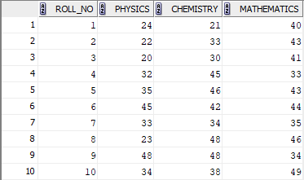

- Find the class average for the subject ‘Physics’

Query :

SELECT AVG(Physics) AS Average_Physics FROM student___56;
Output :

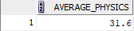

- Find the highest marks for mathematics (To be displayed as highest_marks_maths).

Query :

SELECT MAX(Mathematics) AS Highest_Marks_Maths FROM student___56;

Output :

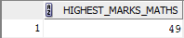

- Find the lowest marks for chemistry(To be displayed as lowest_mark_chemistry)

Query :

SELECT MIN(Chemistry) AS Lowest_Mark_Chemistry FROM student___56;

Output :

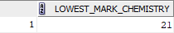

- Find the total number of students who have got a ‘pass’ in physics.

Query :

SELECT COUNT(*) AS Pass_Physics FROM student___56 WHERE Physics>=12;

Output :

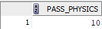

- Generate the list of students who have passed in all the subjects

Query :

SELECT * FROM student___56 WHERE status='pass';

Output :

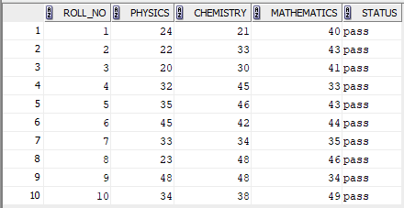

- Generate a rank list for the class. Indicate Pass/Fail. Ranking based on total marks obtained by the students.

Query :

SELECT Roll_no,(Physics+Chemistry+Mathematics) AS TOTAL_MARKS,status FROM student___56;

Output :

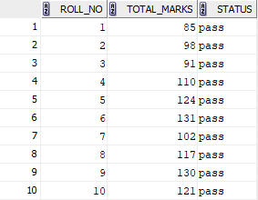

- Find pass percentage of the class for mathematics

Query :

SELECT AVG (Mathematics)as avg_maths from student___56 where status='pass';

Output :

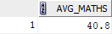

- Find the overall pass percentage for all classes.

Query :

SELECT AVG( Mathematics+Chemistry+Physics) AS avg_of_pass from student___56 where status ='pass';

Output :

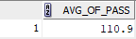

- Find the class average

Query :

SELECT AVG(Physics+Chemistry+Mathematics)AS Class_Average_Total FROM Student___56;

Output :

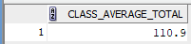

- Find the total number of students who have got a Pass.

Query :

SELECT COUNT(*)AS Total_Passed_Students FROM Student___56 WHERE Physics>=12 AND Mathematics>=25;

Output :

